Forum: General Assembly 3: Social, Humanitarian, and Cultural
Agenda: On measures to protect indigenous populations
Student Officer: Peipei Song

Introduction
Indigenous populations are characterized as people have distinct cultures from the mainstream society, and they are the most marginalized and disenfranchised population in the world. Some examples include the Inuit of the Arctic, the White Mountain Apache of Arizona, the Yanomami and Tupi people of the Amazon, the Maasai in East Africa, and the Bontoc people in the Phillipines. (Cultural Survival) They have suffered from the effects of globalization, which has increased the exploitation of their lands and resources. (First Peoples Worldwide) Indigenous people have retained different social, cultural, economic, and political characteristics and continue to maintain close ties with their environment and pre-settler societies. Currently, about 476 million aboriginals exist across more than 90 countries in the world. Despite only making up 6% of the world’s population, aboriginals comprise 18% of the poverty-stricken people and suffer from inequality and exclusion. Many groups do not have proper infrastructure and access to basic services. Lands occupied by aboriginals are vulnerable to industrialization processes including extractive industries such as mining, oil exploration, logging, and other projects for their rich natural resources. In some cases indigenous groups were forced to evict from their native territories under the name of conservation, but in actuality for exploitation purposes. Albeit protests, there is still a lack of formal recognition over aboriginal land ownership; governments and companies often overlook their voices and their lack of access to justice has not aided their causes. These issues combined have made them one of the most disadvantaged groups in the world. It has also exposed them to the effects of climate change and natural hazards such as a global pandemic like COVID-19. It is General Assembly 3’s mission to draft resolutions that will protect aboriginal populations from land invasion, discrimination, poverty, and marginalization for they protect 80% of the world’s remaining biodiversity and possess knowledge on methods to mitigate climate risks and natural disasters, which offers extensive benefits for countries that are suffering the effects of pollution and assist in designing measures to protect environment ecosystems.

Key Terms
Indigenous populations
Non-dominant distinct cultural groups that have their own social, economic or political systems. They are closely tied with their environment and its natural resources, and maintain ancestral environments and systems as communities.

Land tenure
The legal regime that determines the time period and conditions under which a certain person or group can use the land. Also known as the relationship individuals and groups hold with the land and its natural resources.

Customary Ownership
Land which is owned by indigenous communities and administered in accordance with their customs, as opposed to statutory tenure usually introduced during the colonial period.

Social Marginalization
Downgrading people to the periphery of society and excluding them from the benefits society offers.

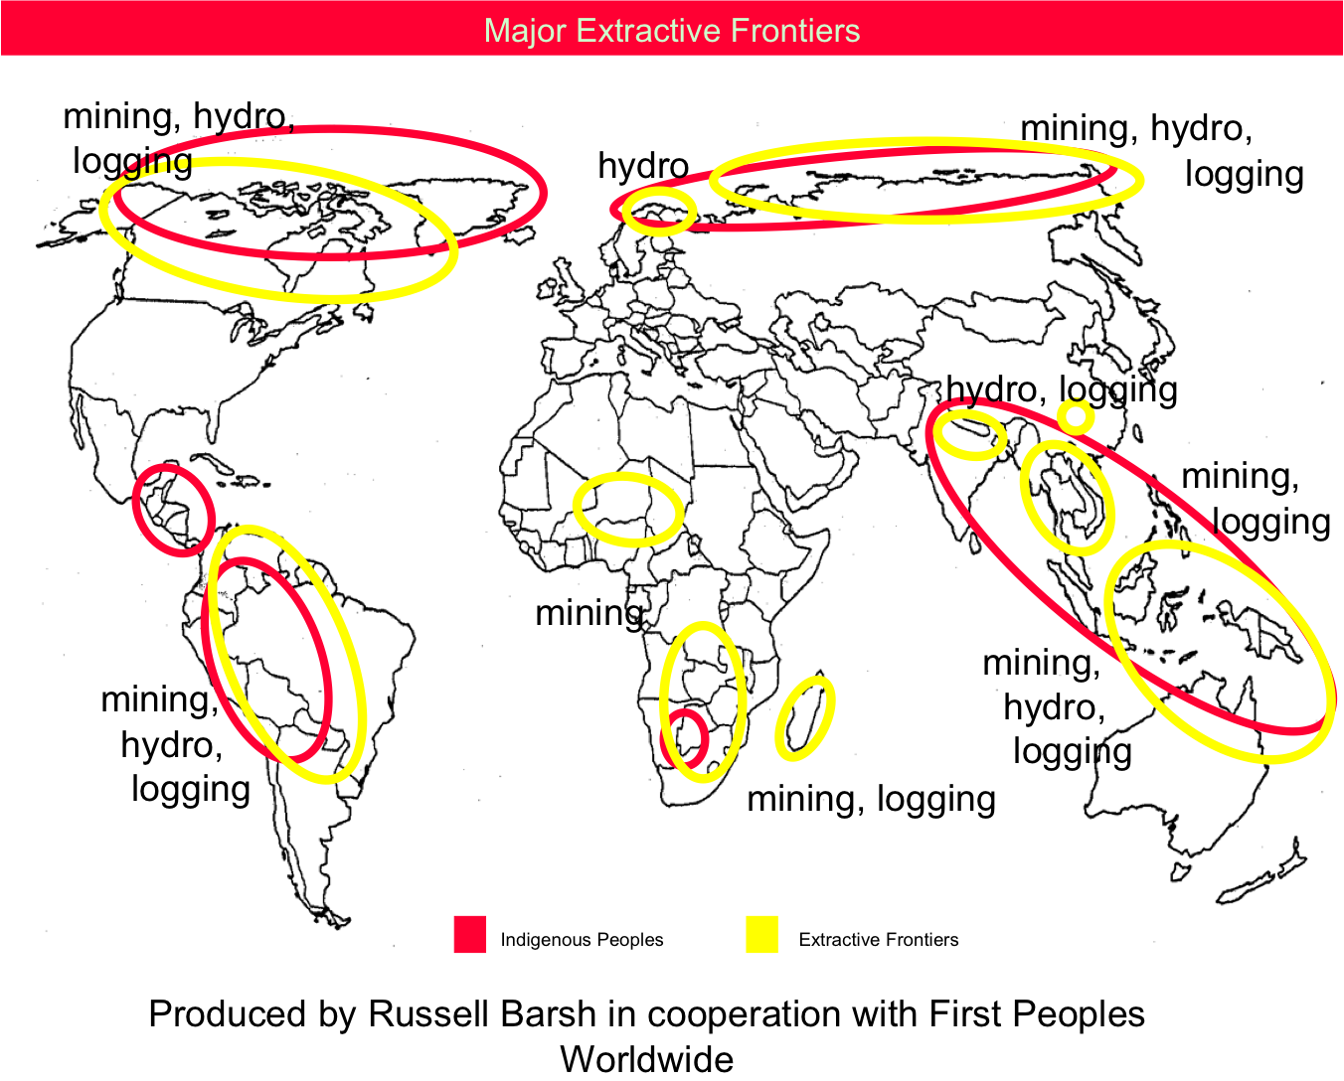
General Overview

Active Threats
Several active threats are posed to indigenous peoples: state discrimination, forced eviction from native lands, the stripping of natural assets, and exploitation of intellectual property. Technological advancements in recent years that allow for large plantation schemes have resulted in environmental degradation in native territories and the forced resettlement of indigenous communities. Indigenous peoples’ identities are based off of social, cultural and spiritual relationships with their land. Despite rising recognition of people’s collective rights, the actual implementation of measures at a national and local level has yet to be achieved. Denial and lack of access to justice raise the difficulty for marginalized indigenous groups to voice their opinions. The Adivasi, or tribal peoples of India, comprise only 8% of the total population of the country, but 40% of them are internally displaced. (IFAD)

Forced Relocation & Displacement
Technological advancements, unsustainable development, The Implementation Gap, and climate change are all factors that have contributed to the displacement and forced relocation of indigenous communities. Commercial agricultural schemes aided by genetically modified seeds and chemical pesticides and fertilizers often mean indigenous territories are given away to large companies without informed consent. In 2008, the Cambodian government granted 20,000 hectares to a Thai company to develop into a sugarcane plantation, forcing the six hundred families living on that land to settle elsewhere. Having lost a relatively stable source of income and food, children had to work in Thailand. Mining, logging, and dam construction projects also contribute to the forced relocation of indigenous families without compensation. While climate change may seem like an environmental issue to most of us, it seriously threatens the livelihoods of indigenous communities, where the majority rely on agriculture as their source of income. If the climate were to continue deteriorating, it will impose severe socioeconomic implications for these communities. (UN) Although there are now more platforms for indigenous people to voice their thoughts, there has been far too little action at the national and local level and their voices are still marginalized. (UN)

Sexual Abuse
Because of their lower status in the mainstream society, indigenous women and children are more prone to rape. Despite recent efforts to achieve gender equality, indigenous groups remain more vulnerable to these crimes. This is largely due to the history of colonization that impedes indigenous women and girls rights to benefit from the same protection non-indigenous people would have. The forced extraction from their territories, in combination with other difficult circumstances such as poverty in indigenous communities heightens the risk of trafficking for women and children. Moreover, indigenous women and girls are vulnerable to violence within their communities that is usually a result of “deeply-rooted patriarchal systems” and practices that place women as subordinate to men. (UN) According to statistics from the Vancouver Rape Relief & Women’s Shelter, indigenous women make up 28% of homicides perpetrated against women in 2019 while representing only 4% of all women in Canada. They are also more than three times as likely to be a victim of male’s partner violence then their non-indigenous counterparts in Canada. (Statistics Canada)

Child Abuse
Child abuse within indigenous communities is one that must be resolved; some contributing factors include but are not limited to poverty, unemployment, loss of identity and self-esteem and imbalance within male and female roles. The COVID-19 situation has complicated the last even more; many indigenous families rely on the men to bring income, but rising unemployment rates mean women are now traveling disproportionate distances to bring basic necessities such as food to the family. Research also indicates that the demonstration of violence in indigenous families is related to intergenerational layers of trauma that comes from the struggle to survive over the years. The stress and pain resulting from this accumulates over time and people that have no other method to release it through end up exhibiting it on their own families. (Australian Institute of Family Studies)

Poverty
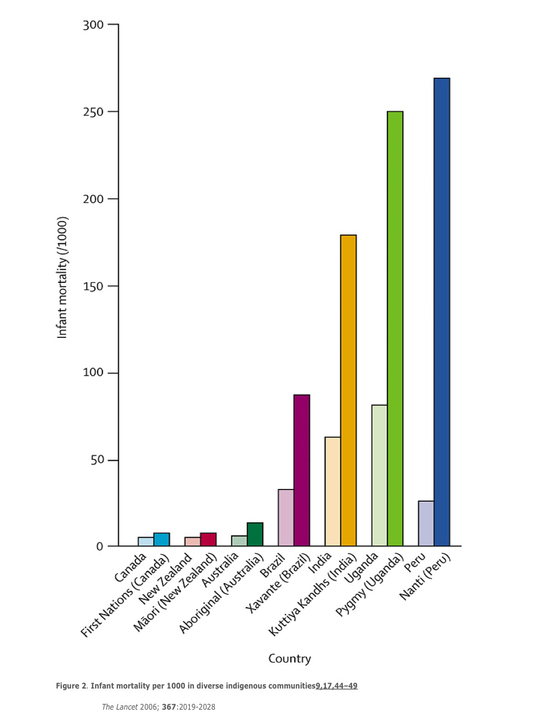
Many indigenous groups suffer from poverty and malnutrition; they have limited access to resources and often lack the most basic necessities. Indigenous peoples make up about one third of the world’s 900 million extremely poor rural people. (IFAD) In Latin America, they account for the poorest demographic in every country. Outside of Latin America, the wealth gap between non-indigenous and indigenous continue to widen in some countries. Impoverished life often forces people to resort to desperate measures; more than 40% of indigenous girls and women in Thailand work in sex trade, and they also account for the majority of females trafficked across borders of southeast Asia. (IFAD)

Health
Indigenous communities suffer from the same infectious diseases at higher rates than non-indigenous do. Endemic and chronic diseases including but not limited to leprosy and diabetes are more prevalent among these communities and tend to be higher in severity and fatality rates. Their life expectancy is up to 20 years lower than that of non-indigenous people; life expectancy for Aboriginal men in Australia is 59 years, compared to 77 for Australian men in general. (Survival International) Increased alcohol and substance abuse directly related to the discrimination they face and lack of social support is also found to be a major health issue for indigenous peoples. Something to look at this year is the social and economic impact of COVID-19 on indigenous communities. Because the people have different understandings of diseases and its treatment from their culture, their traditional healers lack adequate knowledge in the effective prevention and containment of such global pandemics. Lack of proper linguistic and intercultural training further complicates matters because communication cannot be facilitated correctly and some indigenous may even sense fear towards medical staff. Currently more than twelve indigenous groups have reported COVID-19 cases, including the Yukpa in Northern Columbia, Six Nations of the Grand River Territory in Canada, and the Navajo in the United States. In addition, many indigenous communities in South America as well as other regions rely on agriculture for a living, making them more vulnerable to the economic setbacks presented by the coronavirus. The Wayuu in Columbia have been extensively affected by the nation-wide quarantine.(World Politics Review)

Cultural Losses
When indigenous groups are displaced from their native territories and are unable to continue practicing traditions, their distinct cultural norms disintegrate and are forced to assimilate into the dominant culture. Specifically: the loss of language, clan-ship, and traditional knowledge. This is especially saddening because the indigenous have some of the best models of sustainable lifestyle, and to have them be extinguished during a time when sustainability is becoming increasingly important for the environment would be a considerable loss.

Timeline of Events
1957 - International Labor Organization No.107 adopted
1989- International Labor Organization 169 adopted
1991 to Present- 23 ratifications of the Indigenous and Tribal Peoples Convention
2000 - United Nations Permanent Forum on Indigenous Peoples Issues established on July 28 to deal with indigenous issues related to economic and social development, culture, the environment, education, health, and human rights. (UN)
2001 - UN Commission on Human Rights decided to appoint a Special Rapporteur on the rights of indigenous peoples
2007 – United Nations Declaration of Rights of Indigenous Peoples (UNDRIP) adopted in September
Expert Mechanism on the Rights of Indigenous Peoples established
2008 - UN Development Group Guidelines on Indigenous Peoples’ Issues issued
2016 - American Declaration on the Rights of Indigenous Peoples
2017 - 5th plenary of the Intergovernmental Science-Policy Platform on Biodiversity and Ecosystem Services (IPBES) approved the approach for working with indigenous and local knowledge and the establishment of a participatory mechanism for indigenous peoples and local communities (UN)
2018 - Green Climate Fund (GCF) adopted an Indigenous Peoples Policy to ensure that GCF activities are developed and implemented in a way that fosters respect, promotion, and safeguarding of Indigenous peoples. (UN)

UN Involvement, Relevant Resolutions, Treaties and Events
International Labor Organization (ILO) Convention 169
It recognizes the land and property rights for indigenous peoples, equality and liberty for indigenous peoples, and autonomy of indigenous peoples. It was agreed by governments in 1989 but will have no actual effect unless individual countries ratify it.

United Nations Permanent Forum on Indigenous Peoples Issues (UNPFII)
An advisory body to the Economic and Social Council. It was established in 2000 with the mandate to deal with indigenous issues related to economic and social development, culture, the environment, education, health and human rights. (UN)

Expert Mechanism on the Rights of Indigenous Peoples (EMRIP)
The Mechanism provides the Human Rights Council with expertise and advice on the rights of indigenous peoples as set out in the UNDRIP and assists Member States upon request in achieving the ends of the Declaration through the promotion, protection and fulfillment of the rights of indigenous peoples. (UN)

UN Declaration on the Rights of Indigenous Peoples (UNDRIP)
Adopted by the General Assembly in September 2007; it is the most comprehensive international instrument on the rights of indigenous peoples. The declaration establishes a universal framework of minimum standards for the survival, dignity, and well-being of the indigenous peoples of the world and it elaborates on existing human rights standards and fundamental freedoms as they apply to the specific situation of indigenous peoples. (UN)

UN Special Rapporteur on the Rights of Indigenous Peoples (UNSR)
This mandate aims to promote good practices between indigenous people and states, implement international standards regarding indigenous peoples’ rights; make recommendations and proposals on appropriate measures to prevent and remedy violations of the rights of indigenous peoples; report on the human rights situations of indigenous peoples; address specific cases of alleged violations of indigenous peoples’ rights. (UN)

Food and Agricultural Organization (FAO) Policy on Indigenous and Tribal Peoples
This policy was formulated with input from representatives of indigenous peoples, the UN Permanent Forum on Indigenous Issues, FAO management, other UN agencies and experts. It acts primarily as a framework to guide the organization’s work where indigenous people are concerned, including information about indigenous peoples’ livelihoods, world views and concerns about development, defines a series of thematic areas where collaborative opportunities are most feasible, and also includes potential methods that will assist in the cooperation with indigenous peoples. (FAO)

International Fund for Agricultural Developments Policy on Engagement with Indigenous Peoples
Approved in 2019, IFAD’s policy aims to enhance IFAD’s development effectiveness with indigenous peoples’ communities in rural areas, and to empower them by overcome poverty by building upon their identity and culture. (IFAD)

Indigenous People’s Forum
Established by IFAD, the Forum aims to promote dialogue and consultation among indigenous peoples’ organizations and institutions, IFAD staff and Member States. It has helped to set the strategic direction for IFAD’s engagement with indigenous peoples, which translates into the economic empowerment of indigenous peoples, especially women and youth. (IFAD)

Indigenous Peoples Assistance Facility
A funding organization that helps indigenous communities find solutions to difficulties they face. IPAF supports projects designed and implemented by indigenous peoples’ communities and their organizations through small grants ranging from US$20,000 up to US$50,000 for a maximum duration of two years. Supported projects build on indigenous peoples’ culture, identity, knowledge and natural resources. The objective is to build a direct partnership with indigenous peoples to enable them and their communities to design and implement grass-root development projects based on their own perspectives. IPAF has contributed to indigenous communities in these areas: improve sustainable agricultural practices, develop new off-farm enterprises and enhanced market access, develop capacity on indigenous peoples’ rights, revitalize cultural heritage and traditional knowledge, map indigenous territories and cultures, empower indigenous women, boost disaster and climate change risk management based on traditional knowledge and practices, preserve and promote local varieties of traditional crops. More information on IPAF projects approved in Africa, Asia and the Pacific, and Latin America and the Caribbean can be found on their website listed in the bibliography. (IFAD)

UNDP and Indigenous Peoples: A Policy of Engagement
A policy note that provides an overview of the United Nations Development Programme’s (UNDP) policy and engagement with indigenous peoples based on its mandate from the Charter of the United Nations, which states: ‘We the peoples…reaffirm faith in fundamental human rights, in the dignity and worth of the human person… (and) promote social progress and better standards of life in larger freedom.’ (UNDP)

UNEP and indigenous peoples: a partnership in caring for the environmental policy guidance
Policy guidance to the United Nations Environment Programme (UNEP) that offers a better understanding and to build on the indigenous peoples’ rights, knowledges, practices, and systems that provide framework for the harmonious relationships indigenous peoples have with their environment. It also works to ensure the inclusiveness of indigenous peoples in UNEP projects and stresses the importance of the partnership with them in developing and implementing environmental policies on a regular basis. (UNEP)

World Bank Indigenous Peoples’ Policy and Program Initiatives
Established first in 1982, the policy was initially designed to consider the needs of relatively isolated and unacculturated tribal groups affected by development projects. It focussed mainly on the protection of land rights and the provision of health services, particularly in relation to forest-dwelling indigenous peoples in lowland South America. The policy was revised in 1991 to include more indigenous groups under its scope. In addition to its original protective measures, the new policy also addresses indigenous peoples’ rights to participate in and benefit from development projects. (World Bank)

UNREDD Guidelines on Stakeholder Engagement in REDD+ Readiness, With a Focus on the Participation of Indigenous Peoples and Other Forest-Dependent Communities
Guidelines that contain relevant policies on indigenous peoples and other forest dependent communities, principles and guidance for effective stakeholder engagement, and practical steps on how to plan and implement effective consultations. (UNREDD)

UN-HABITAT: Housing Indigenous People in Cities: Urban Policy Guides for Indigenous Peoples
Guidelines to improve housing conditions for indigenous peoples who face large-scale dispossession and degradation of their lands, resources, and territories. Examines housing situations for indigenous peoples in various countries and assesses faults in housing and development policies and programmes.

Survival International
A volunteer organization that speaks against natural resource exploitation on indigenous territories and voice for indigenous rights. Their mission statement reads, “We stop loggers, miners, and oil companies from destroying tribal lands, lives, and livelihoods across the globe. We lobby governments to recognize indigenous land rights. We document and expose the atrocities committed against tribal people and take direct action to stop them. We give tribal peoples a platform to speak to the world.”

International World Group for Indigenous Affairs (IWGIA)
A global human rights organization dedicated to promoting, protecting, and defending indigenous peoples’ rights. The organization publishes their report “The Indigenous World” annually, which contains in-depth updates to the state of indigenous groups all over the world. (IWGIA)

Possible Solutions
Strengthening governance
Governments of individual countries should strive to work actively in the regulation of charity funds with a third party to ensure that funds are entirely received by the indigenous communities and the effective national and local implementation of protection policies that extends beyond simply recognizing said policies.

Supporting indigenous livelihoods for resilience
Encourage support for farms and tourism companies run by indigenous people through means such as but not limited to advertising through social media.

Conducting assessments to improve healthcare
Conduct studies on indigenous health practices and roles of community members for better intercultural and linguistic training of medical staff; train indigenous individuals to become medical staff and work closely with traditional healers to educate them on proper medical knowledge.

Education
Develop education programs for indigenous people starting from pre-school to secondary school that are bilingual and compatible with indigenous community life. By learning about their native language and culture as well as the local ones, they will be able to retain their cultural values and possess the skills to navigate society as any other non-indigenous person should. Funding structures should also be established to support indigenous students who wish to pursue higher education. An example of such is the American Indian College Fund, which is the U.S.’s largest charity supporting Native American students who want to attend college and graduate school.

Raise Awareness
Organize community activities or, even better, nation wide holidays that celebrate indigenous culture and offer the opportunity for non-indigenous people to form closer relationships with the indigenous through interactive activities. Reconciliation Canada is an organization that aims to improve the relationship between the two groups through awareness, outreach programs and workshops.

Bibliography
Author Ellen L. Lutz. “Indigenous Peoples and Violent Conflict: Preconceptions, Appearances, and Realities.” Cultural Survival, 1 Mar. 2005, www.culturalsurvival.org/publications/cultural-survival-quarterly/indigenous-peoples-and-violent-conflict-preconceptions.
Burke, Caroline. “8 Indigenous Rights Groups To Support On Indigenous Peoples' Day This Year.” Bustle, Bustle, 8 Oct. 2020, www.bustle.com/life/8-indigenous-rights-groups-to-support-on-indigenous-peoples-day-this-year-18814669.
“Causal Factors of Family Violence and Child Abuse in Aboriginal Communities.” Child Family Community Australia, 2019, aifs.gov.au/cfca/publications/child-abuse-and-family-violence-aboriginal-communities/causal-factors-family-violence.
“Environment For Indigenous Peoples.” United Nations, United Nations, 2019, www.un.org/development/desa/indigenouspeoples/mandated-areas1/environment.html.
‘Regional consultation on the rights of indigenous peoples in Asia’. https://undocs.org/A/ HRC/45/34/Add.3. Accessed 30 Oct. 2020.
Environment, UN. “Indigenous Issues.” UNEP - UN Environment Programme, 2020, www.unenvironment.org/civil-society-engagement/partnerships/indigenous-issues.
Environment | United Nations For Indigenous Peoples. https://www.un.org/development/desa/indigenouspeoples/mandated-areas1/environment.html. Accessed 30 Oct. 2020.

FirstPeoples.Org - The Challenges We Face. http://www.firstpeoples.org/the-challenges-we-face.htm. Accessed 30 Oct. 2020.

Gracey, Michael, and Malcolm King. ‘Indigenous Health Part 1: Determinants and Disease Patterns’. The Lancet, vol. 374, no. 9683, July 2009, pp.65–75. www.thelancet.com, doi:10.1016/S0140-6736(09)60914-4.
https://plus.google.com/+UNESCO. ‘UN Policies on Indigenous Peoples’. UNESCO, 20 Sept. 2017, https://en.unesco.org/indigenous-peoples/un-policies.

“Housing Indigenous Peoples in Cities: Urban Policy Guides for Indigenous Peoples: UN-Habitat.” UN, 2020, unhabitat.org/housing-indigenous-peoples-in-cities-urban-policy-guides-for-indigenous-peoples.
‘UNESCO Policy on Engaging with Indigenous Peoples’. UNESCO, 3 Sept. 2017, https://en.unesco.org/indigenous-peoples/policy.
In South America, Indigenous People Face a ‘Threat to Their Very Survival’ From COVID-19. https://www.worldpoliticsreview.com/trend-lines/28771/in-south-america-indigenous-people-face-a-threat-to-their-very-survival-from-covid-19. Accessed 30 Oct. 2020.

‘Indigenous Peoples’. World Bank, https://www.worldbank.org/en/topic/indigenouspeoples. Accessed 30 Oct. 2020.

Indigenous Peoples at the United Nations | United Nations For Indigenous Peoples. https://www.un.org/development/desa/indigenouspeoples/about-us.html. Accessed 30 Oct. 2020.

Issues. http://www.culturalsurvival.org/issues. Accessed 30 Oct. 2020.

Montenegro, R. A., & Stephens, C. (2006). Indigenous health in Latin America and the Caribbean. Retrieved October, 2020, from https://www.who.int/social_determinants/resources/articles/lancet_montenegro.pdf

Notess, Laura. “For Indigenous Peoples, Losing Land Can Mean Losing Lives.” World Resources Institute, 14 Nov. 2018, www.wri.org/blog/2018/05/indigenous-peoples-losing-land-can-mean-losing-lives.
OHCHR | Special Rapporteur on the Rights of Indigenous Peoples. https://www.ohchr.org/EN/Issues/IPeoples/SRIndigenousPeoples/Pages/SRIPeoplesIndex.aspx. Accessed 30 Oct. 2020.

Protect Indigenous People’s Land Rights and the Whole World Will Benefit, UN Forum Declares | UN DESA | United Nations Department of Economic and Social Affairs. 17 Apr. 2018, https://www.un.org/development/desa/en/news/social/unpfii17-opening.html.

“Stats about Indigenous Women in Canada.” Stats about Indigenous Women in Canada | Vancouver Rape Relief & Women's Shelter, 2019, www.rapereliefshelter.bc.ca/blog/stats-about-indigenous-women-canada.
Tribal Communities Suffer When Evicted in the Name of Conservation. https://www.downtoearth.org.in/blog/forests/tribal-communities-suffer-when-evicted-in-the-name-of-conservation-64376. Accessed 30 Oct. 2020.

Turkewitz, Julie. ‘Indigenous Groups Isolated by Coronavirus Face Another Threat: Hunger’. The New York Times, 9 Apr. 2020. NYTimes.com, https://www.nytimes.com/2020/04/09/world/americas/indigenous-coronavirus-hunger.html.

UNDP and Indigenous Peoples: A Policy of Engagement. 2020, www.undp.org/content/undp/en/home/librarypage/environment-energy/local_development/undp-and-indigenous-peoples-a-policy-of-engagement.html.
UNPFII | United Nations For Indigenous Peoples. https://www.un.org/development/desa/indigenouspeoples/unpfii-sessions-2.html. Accessed 30 Oct. 2020.

UNPFII Seventeenth Session: 16-27 April 2018 | United Nations For Indigenous Peoples. https://www.un.org/development/desa/indigenouspeoples/unpfii-sessions-2/2017-2.html. Accessed 30 Oct. 2020.

UNPO: ILO Convention 169: 20 Years Later. https://www.unpo.org/article/9746. Accessed 30 Oct. 2020.

Who are indigenous peoples? - United Nations. (n.d.). Retrieved October 30, 2020, from https://www.un.org/esa/socdev/unpfii/documents/5session_factsheet1.pdf

‘WHO | Indigenous Populations’. WHO, https://www.who.int/topics/health_services_indigenous/en/. Accessed 30 Oct. 2020.

Contact Information:
Please contact me or people listed below with any questions regarding the speech or report. Good luck!

Chair Peipei Song
Email: peipei-song@dongguan.qsi.org

Jack – Head of Chairs
22jkim@student.uiszc.org

Helen Wong- Secretary General
21hwong@student.uiszc.org

Gregory Peebles – Director of U2NESCO
gpeebles@uiszc.org

