Forum: Education Committee
Agenda: On measures to provide a safe environment for students to learn (ii)
Student Officer: Earn Lau

Introduction
Having good education is vital, it is a critical component in escaping poverty and ensuring long term sustainability. As the world is improving, there were improvement in promoting educational equity, and student enrolment rates across the world have increase, particularly for girls. Nevertheless, this is still a huge issue; as in 2018 about 258 million children and youth are out of school, while about half of the youth today are not skilled in reading and writing. The latest Covid-19 pandemic has made the safety of pupils learning in educational facilities less certain. The prolonged time of school closures harmed counties economic opportunities, decreased access to enough supplies for pupils and imposed financial burdens on families. In order to let students still have access to education, online school was implemented. Schools have established online learning environments to enhance inclusive learning settings. This benefits students to take more responsibility in thier learning and decreased housing expenses and indebtedness in certain boarding schooling programs. However, considerations such as restricted in class learning, the disadvantages of social contacts, and unhealthy lifestyles raise concerns about the feasibility of completely replacing the original setting with digital learning. Reduced social connection may result in impediments to globalization and community bonding. As United Nations Sustainable Development Goals 4 have suggest it is our responsibility to uphold education in an ever-changing world and offer better and safer learning settings for children.
Although Covid 19 is an issue we need to look into, the ongoing conflict in the Middle East, such as Yemen or African countries, and the attacks on children continue to occur. A safe environment also suggests its surroundings and the state of “corruptness” the country is in. It is true that we have come to an agreement that wars should not affect children, in any shape or form, however current events in areas from the middle east have proved that we are not reaching the concusses we aggreged on. In 2017, an estimated 26,445 people died from terrorism globally. The Middle East, Africa, and South Asia accounted for 95% of the total. Europe, the Americas, and Oceania collectively accounted for less than 2% of all deaths.With no genuine education, a country would not improve while future generation would not be able to contribute to a country’s development; In these situations this would only degrade . This will simply aggravate the population's hopelessness in impoverished countries. In some developed countries like the United States, school shootings come off as often, Over 3,000 children and teenagers have been shot and murdered, with another 15,000 being wounded. Every year, over 3 million teenagers in the United States are exposed to gun violence.

Before diving deeper in the topic, it is important to understand, what defines safe environment and why education is important. In law, the definition of a safe environment refers to “ [the] duty of care is discharged by taking steps to keep all those in our care safe and free from abuse;” This suggest that life's mounting dangers, no place on the planet is secure. But the importance of education still lies, it would make the world a safer place if we could at least provide a fair future for future generations in a secure learning environment, preparing them to become conscientious individuals. It will take us longer to improve the world without this good foundation of education for everybody. However the question still lies, “ should everyone have the right to education ?” We can imagine the society into multiple working classes, including:
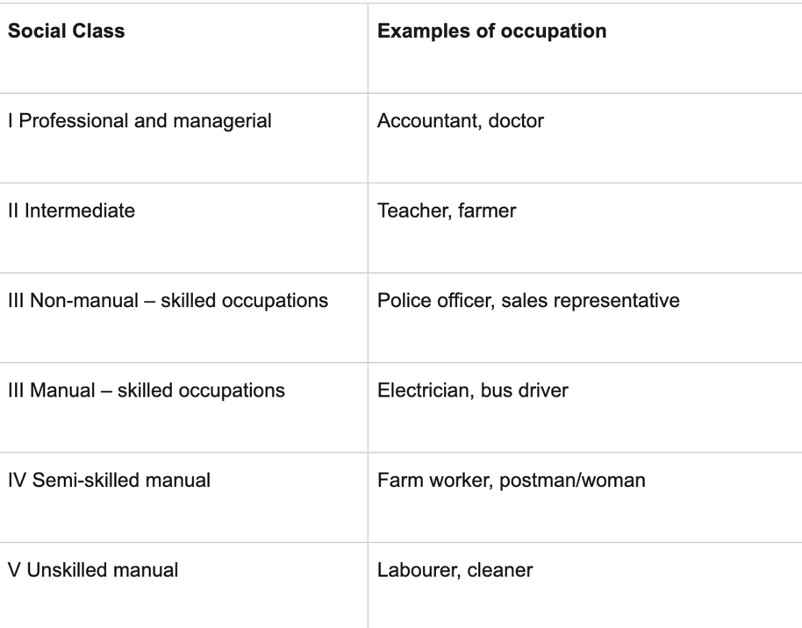
People thrive for getting a better job to improve the quality of life, although some might argue that reciving good eduction does not nessarly imply that indivisuals can garentee an elite job; Though, over the years it is proven that reciving quality education increase the chance of obtaining elite jobs. If everyone acquire fair and adequate education it would derange the different working class causing inbalnce ratio between professionals and unskilled workers, this would be a problem in the future.
Key Terms
Exploitation- the act of profiting or otherwise benefiting oneself by exploiting someone or a group of people for personal gain.
Inclusion- Inclusion in education refers to how all students are regarded equally, treated with respect, and given equal access to learning opportunities. When developing education, educators consider a variety of learning modes such as auditory, visual, and kinesthetic.
Perental responsibility- The majority of cases of child abuse and neglect are the result of parental failures to protect their children. For their child's benefit, it is their functional obligation to give primary care. At-risk families who are unable to care for their children are subjected to a child abuse investigation and, if required, are advised to seek help from adoption or foster care agencies.
Child labor- Child labor is described as employment that is hazardous to children's mental, physical, social, or moral development and interferes with their education, such as denying them the chance to attend school. However families and the child itself is proud of themselves since the child is providing finantial stability to the household, this is an idea that is hard to change from the familes.
Child abuse- Physical abuse, child sexual abuse, failure to meet a child's needs/failure to protect an abused kid, and manipulation are all examples of child abuse. This does not only happen in LEDCs but also MEDCs.
General overview
For millennia, there have been debates over child safety in order for children to learn in educational institutions securely. Until today, historical and present evidence shows that prior answers were never strong since it was the most difficult issue for everyone to handle. But possible solutions could be brought up if we untie together.
Defining “safe environment” can be divided into two catagories, internal and external. Internal implicit situations happening in educational institution. Sanarios like teachers abusing students, educating inappropate content and uncertified and qualified teachers are examples of an unsafe environment internally. External unsafe environment suggest the physical aspects; school shooting, wars occurring while students are getting educated in school and school bullying can be examples of external unsafe eniviroments.
The link between education and humanitarian crisis has a big connection towards the worldwide deterioration and suffering of children's educational surroundings, which has posed a direct threat and harm to many people in communities. Children are most frail component in these situations, making them most susceptible. Every day, innocent children are exposed to every painful violence in a disaster situation, and families are ripped apart by migration. 3.5 million school-age refugees had 0 days of school in 2016. Throughout the history of mankind, this wicked and violent conduct has been slammed on everyone in the world for the entirety of human history, and there no line between these boundaries. This happens everywhere including in homes, schools, countries, online settings and as well as in families. However, the question of whether or not the countries in the refugee camp should be the ones to provide education, as it would not assist their own country, remains unanswered.
In most developing countries, poverty burdens the chance of having education and the quality of education. With the pandemic still going on, developing countries are priorities we need to support when it comes to these issues. It is also not different in more developed countries; owing to the fact that students are stranded at home because of the epidemic in wealthy countries. There must be measures to ease the family's extended time of quarantine in order to maintain children's quality of education and parents' economic well-being.
Keep in mind that school and education is different. School is a place where education is revied while education the act of imparting knowledge to others and the act of receiving information from another. Education does not only provide knowledge but also teaching what is right and wrong and different skills like personal management, critical thinking, problem solving skills etc. Contrarily, Education may be utilized in cruel ways, such as in cultural traditions that pose serious hazards to the future of girls and boys across the world, millions of teens girls are subjected to early marriage and female circumcision both of which are against international human rights agreements. It is our priority and prepose to safeguard these children from violence, abuse, and exploitation, and to provide them with an excellent education so that they can safely develop in to successful adults and contribute to the world.

Major parties involved
● UNICEF (United Nations Children Fund)
UNICEF is the United Nations Children's Fund, which works in the world's most difficult areas to reach the world's most vulnerable children and adolescents, as well as to safeguard the rights of all children everywhere. It was formed when the United Nations was established in 1945. Their goal is to “aim to make the world a safe place for children to thrive.” According to the United Nations Economic and Social Council, the most important goal is to maintain and increase family social security while reducing social exclusion. Its tasks range beyond government entities and include community collaboration.

● Children International
Children international is Founded in 1936, Children international is a non-profit humanitarian organization that works to break the cycle of poverty for children throughout the world. Children International has been declared one of the top humanitarian organizations in the United States and is a top-rated charity. Others can soupport them by donating or sponsering children. They have help over 200,000 kids in getting a education.
● Save the children
Founded in 1919, Save the Children was the first international organization dedicated to meeting the needs of children and protecting their rights. Its principal goal is to safeguard and enhance children's health and education across the world. Since them they have changed the lives of over 197 million children. They have help by finantially soupporting families, providing education and delivering emergency care. In Yemen, it operates the world's largest humanitarian assistance station, which can serve 23 hospitals and 88 health facilities.
● United Kingdom:
In England, the Children Act of 1989 establishes a legal foundation for child protection. The importance of the child's wellbeing is one of the key concepts established by the Act. the standards and expectations around child-care responsibilities. The goal of this Act was to keep families together and provide protection for children. Every child has the right to be protected against abuse and exploitation, as well as the right to have investigations into their welfare, under the Children Act of 1989.
●African Nations:
Sub-Saharan Africa has the greatest rates of education exclusion of any area.Over one-fifth of children between the ages of 6 and 11 are out of school, followed by one-third of adolescents aged 12 to 14. According to UIS data, about 60% of young people between the ages of 15 and 17 do not attend school. Especially, teen girls are targeted to, violence, abuse and exploitation. Nearly one in three teenage girls have been beaten or hit since the age of 15, and one in 10 raped or sexually abused. Although, armed forces are implemented this is still a large problem.

●Asian Nations:
In Asian culture it is belived that good education is the only was to sucuess. Parents stress on the importance of education, the competitive nature of attending a good school/university pressures children itself; mental helth is not as significant compared to academics. As for children that is not as wealthy most of them chimes into child labor or it is harder for them to attend scool since the wealthy have took most of the spots. Since the beginning of the COVID-19 pandemic in early 2020, the education of more than 800 million children – 400 million in South Asia, 260 million in East Asia, and 140 million in Southeast Asia – has been disrupted due to school closures across Asia, with more than 27 million of them waiting more than a year to return to their classrooms,
Timeline of Events
1924- The Geneva Declaration on the Rights of the Child was accepted by the League of Nations, and it was authored by Eglantyne Jebb, the founder of the Save the Children foundation. The proclamation stressed children's rights to economic independence, self-defense, development, and the ability to seek special assistance when necessary.
1946- For the first time, the United Nations General Assembly established non-governmental organizations such as UNICEF, the International Children's Emergency Fund, to safeguard children across the world.
1959- The United Nations General Assembly enacted the Declaration on the Rights of the Child, which affirms that all children have the right to an education, to play, and to a safe and healthy environment.
1991- In 1995, a meeting of experts from UNICEF, Save the Children, and Defence for Children International resulted in the formation of the Child Rights International Network (CRIN), a new international organization that challenges the status quo through fact-based research rather than campaigning and movements.
2002- Child representatives addressed the General Assembly for the first time at the United Nations special session on children, outlining the unique aspirations and future prospects of children.
2015- 196 other countries, including Somalia and South Sudan, have already adopted the Treaty on the Rights of the Child.
2018- Stoneman Douglas High School shooting have killed 17 students and 17 injuries. As in 2018 more than 278,000 students have experienced gun violence in school.

UN Involvement, Relevant Resolutions, Treaties and Events
The Declaration of the Rights of the Child, which specifies rights to education, protection, healthcare, proper nutrition, and housing, has been endorsed by the United Nations since 1959. With the foundation of UNICEF, the Declaration of the Rights of the Child was expanded into the Convention on the Rights of the Child
Convention on the Rights of the Child suggests that Instead of viewing children as inert objects in need of charity and care, it transformed how children are regarded and treated, transforming them into valuable human beings with equal rights. It shown significant benefits in falling infant mortality and increased school enrollment through this international accord.
The United Nations issued proposals in 2006 to stop violence against children, and then Secretary-General Kofi Annan designated chosen delegates to oversee implementation. UNESCO has partnered with multiple organization such as World Health Organization , World Food Programme, to accomplish the Sustainable Development Goals (SDGs) by 2030.

Possible Solutions
The greatest human development index is attained by three characteristics, according to the United Nations Development Programme "Long and healthy life," "Knowledge," and "A fair level of living." Education is the crucial foundation for the other two criteria on this list. We couldn't completely determine a country's progress based merely on its prospects for tremendous riches, high GDP, and GNP. With educations being halted in some places due to the Covid-19, the chaos resulted in an increase in crime rates, and the economy naturally suffered in specific MEDC countries where there aren't enough graduates for jobs opportunities and for local companies and government to hire, both of which have an indirect and direct impact on the child's education progress. If all leaders and professionals could contribute significantly to enhancing the educational system, average education could be extended to all children.
- Improving online facilities and educational intrusions can be a way to reach “education” to most of the children in the world. Today technology and the internet is an powerful tool to utilize, with modern routing network and satellites linking the whole world of our planet, being unable to connect to the internet will not be a major concern, but students being interrupted by other factors will be a major issue that we must address. Using online free resources like Khan academy, Coursera and MIT OpenCourseware can decrese the chance of children being exposed to dangerous situation that might take another innocent life away.

- Countries itself can start developing policies that provide their citizen the chance of returning to school under the temporary supervision of different experts. This might losen the perssure for less wealthy families. This method can also be followed by parents in a household whose economy is based on revenue from primary industrial work.

Bibliography:
- ‌ “6.1 the Safe and Supportive Schools Resolution | SFUSD.” Sfusd.edu, 2014, www.sfusd.edu/services/know-your-rights/student-family-handbook/chapter-6-student-discipline/61-safe-and-supportive-schools-resolution. Accessed 1 Dec. 2021
- “Security Council Adopts ‘First of Its Kind’ Resolution on Protecting Classrooms from Conflict.” UN News, 29 Oct. 2021, news.un.org/en/story/2021/10/1104482. Accessed 30 Oct. 2021.
- “General Assembly Proclaims 9 September International Day to Protect Education from Attack, Adopting Resolution in Silence Procedure | Meetings Coverage and Press Releases.” Un.org, 2020, www.un.org/press/en/2020/ga12246.doc.htm. Accessed 23 Oct. 2021.
- “UNICEF.” Unicef.org, 2018, www.unicef.org/. Accessed 1 Dec. 2021.
- ‌ “Education in Africa | UNESCO UIS.” Unesco.org, 2019, uis.unesco.org/en/topic/education-africa. Accessed 1 Dec. 2021.
- “Child Protection.” Unicef.org, 2018, www.unicef.org/wca/what-we-do/child-protection. Accessed 22 Oct. 2021.
- ‌ “Humanitarian Aid Organization for Children.” Save the Children, 2021, www.savethechildren.org/. Accessed 11 Oct. 2021.
‌
- “What We Measure | What We Focus on | Children International | Child Sponsorship in Africa, India, South America, & USA.” Children International, 2018, www.children.org/see-the-impact/charity-programs/what-we-measure. Accessed 17 Oct. 2021.
- ‌ Child Welfare Policy Primer: A Guide for Advocates, Policymakers, and Others Interested in Child Welfare Policy Reform M a Y 2014.
‌
- “Education Gap Grows Between Rich and Poor, Studies Say (Published 2012).” The New York Times, 10 Feb. 2012, www.nytimes.com/2012/02/10/education/education-gap-grows-between- rich-and-poor-studies-show.html. Accessed 21 Oct. 2021.
- Fox, Michelle. “Coronavirus Has Upended School Plans. It Will Also Worsen Racial and Economic Inequalities, Experts Warn.” CNBC, CNBC, 12 Aug. 2020, www.cnbc.com/2020/08/12/impact-of-covid-19-on-schools-will-worsen-racial-inequity-experts- say.html. Accessed 11 Oct. 2021.
- “Social Class – an Introduction to the Concept.” ReviseSociology, 4 Aug. 2016, revisesociology.com/2016/08/04/social-class-definition-introduction/. Accessed 11 Dec. 2021.
- https://www.facebook.com/washpostvisuals. “More than 278,000 Students Have Experienced Gun Violence at School since Columbine.” Washington Post, 20 Apr. 2018, www.washingtonpost.com/graphics/2018/local/school-shootings-database/. Accessed 13 Dec. 2021.
- “The Future of 800 Million Children across Asia at Risk as Their Education Has Been Severely Affected by the COVID-19 Pandemic.” Unicef.org, 2021, www.unicef.org/eap/press-releases/future-of-800-million-children-across-asia-at-risk. Accessed 23 Dec. 2021.

‌

Contact Information:
Please contact me or people listed below with any questions regarding the speech or report. Good luck!
Co-Chair: Earn Lau
Wechat ID: wechat_earnmoney
William Chen– Head of Chairs
22wchen@student.uiszc.org
Jack - Secretary General
22jkim@student.uiszc.org
Bernard Opanga – Director of U2NESCO
bopanga@uiszc.org

‌

‌

